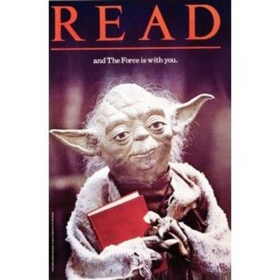Independent Reading—Fall, 2013

DUE WEDNESDAY, NOVEMBER 20th: You will create a READ poster that represents your book in some way and present that poster to the class in small groups.

- You can use your artistic talent or photography skills to create your poster.
- It should be typical copy paper sized.
- Your READ poster should include:
  - An image of a significant aspect of your book (think symbolic)
  - The word READ
  - The title and author of your book
- We will have a contest, and the READ poster given top honors by all my classes will be made into a poster for our classroom.

On Wednesday, November 20th, you will share your poster and do the following:

- In class, you will also be asked to respond to the following question:

Writers do not write unless they have something to say. This “something” is the main idea or central message of a piece of work – or in simpler terms, the theme. For this portion of the project, you will determine the theme of your novel, and using specific examples from the story (direct quotes) justify and explain why you chose this theme. This is a position paper, which means that you are taking a stand on an issue. Choose one theme and one theme only! Do not be wishy-washy in your reasoning! Stick to your evidence and PROVE to me this is the theme of your story. Write with authority, but do not use the first person (“I”).

READ Poster and Response=Summative Assessment Grade

